# EXPERIMENT 3(a)

Objective:

To study the Frequency Response of Common Emitter Amplifier and calculate its Bandwidth.

Components:

|  |  |  |
| --- | --- | --- |
| S.No. | Name | Quantity |
| 1 | Transistor BC107/BC547 | 1(One) No. |
| 2 | Resistors (100KΩ 10KΩ, 1KΩ) | 1(One) No. Each |
| 3 | Resistors (2.2 KΩ) | 2(Two) No. |
| 4 | Capacitors (10µF) | 2(Two) No. |
| 5 | Capacitors (100µF) | 1(One) No. |
| 6 | Bread board | 1(One) No. |

Equipment:

|  |  |  |
| --- | --- | --- |
| S.No. | Name | Quantity |
| 1 | Dual DC Regulated Power supply  (0 – 30 V) | 1(One) No. |
| 2 | DSO/CRO(0-20MHz) | 1(One) No. |
| 3 | Function Generator (0-1MHz) | 1(One) No. |
| 4 | Connecting wires (Single Strand) |  |

Theory:

The common emitter configuration is widely used as a basic amplifier as it has both voltage and current amplification. See fig. 1. for the circuit diagram for the experiment.

Resistors R1 and R2 form a voltage divider across the base of the transistor. The function of this network is to provide necessary bias condition and ensure that emitter-base junction is operating in the proper region.

In order to operate transistor as an amplifier, biasing is done in such a way that the operating point is in the active region. For an amplifier the Q-point is placed so that the load line is bisected. Therefore, in practical design VCE is always set to VCC/2. This will confirm that the Q-point always swings within the active region. This limitation can be explained by maximum signal handling capacity. For the maximum input signal, output is produced without any distortion and clipping.

The Bypass Capacitor:

The emitter resistor RE is required to obtain the DC quiescent point stability. However the inclusion of RE in the circuit causes a decrease in amplification at higher frequencies. In order to avoid such a condition, it is bypassed by a capacitor so that it acts as a short circuit for AC and contributes stability for DC quiescent condition. Hence capacitor is connected in parallel with emitter resistance.

The Input/ Output Coupling (or Blocking) Capacitor: An amplifier amplifies the given AC signal. In order to have noiseless transmission of a signal (without DC), it is necessary to block DC i.e. the direct current should not enter the amplifier or load. This is usually accomplished by inserting a coupling capacitor between two stages.

CC- Output Coupling Capacitor

CB- Input Coupling Capacitor

Frequency response of Common Emitter Amplifier:

Emitter bypass capacitors are used to short circuit the emitter resistor and thus increases the gain at high frequency. The coupling and bypass capacitors cause the fall of the signal in the low frequency response of the amplifier because their impedance becomes large at low frequencies. The stray capacitances are effectively open circuits.

In the mid frequency range large capacitors are effectively short circuits and the stray capacitors are open circuits, so that no capacitance appears in the mid frequency range. Hence the mid band frequency gain is maximum.

At the high frequencies, the bypass and coupling capacitors are replaced by short circuits. The stray capacitors and the transistor determine the response.

Characteristics of CE Amplifier:

1. Large current gain.
2. Large voltage gain.
3. Large power gain.
4. Current and voltage phase shift of 1800.
5. Moderated output resistance.

Circuit Diagram:

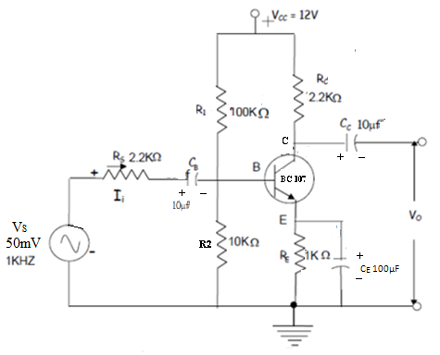Fig.1. Circuit Diagram For Experiment 3(a)

Procedure:

1. Connect the circuit as shown in the circuit diagram.
2. Set source voltage VS = 50mV (say) at 1 KHz frequency using the function generator.Observe the phase difference between input and output by giving these two signals to the dual channels of CRO.
3. Keeping input voltage constant, vary the frequency from 10 Hz to 500KHz in regular steps and note down the corresponding output voltage. Calculate gain in dB as shown in the tabular column.
4. Plot the graph: gain (dB) verses Frequency on a semi log graph sheet.
5. Calculate the 3-dB bandwidth from the frequency response.

Expected waveform:

(a) The Input & Output Waveforms at 1 KHz

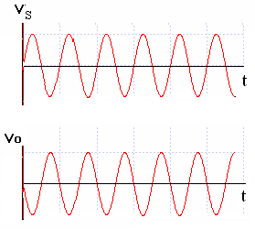

(b) Frequency Response Curve

In the usual application, mid band frequency range are defined as those frequencies at which the response has fallen to 3dB below the maximum gain (|A| max). These are shown as fL and fH and are called as the 3dB frequencies (Lower and Upper Cut-Off Frequencies respectively). The difference between higher cut-off and lower cut-off frequency is referred to as bandwidth (fH - fL).

*Fig.2: Frequency Response Curve*

Calculations from the graph

Bandwidth = fH – fL (in Hz)

Observation tables:

VS = 50mV

|  |  |  |  |  |
| --- | --- | --- | --- | --- |
| S.NO. | Frequency | Vo(Volts) | Gain = Vo/Vs | Gain(dB) = 20 log(Vo/Vs) |
|  |  |  |  |  |
|  |  |  |  |  |
|  |  |  |  |  |
|  |  |  |  |  |
|  |  |  |  |  |
|  |  |  |  |  |
|  |  |  |  |  |
|  |  |  |  |  |
|  |  |  |  |  |
|  |  |  |  |  |
|  |  |  |  |  |
|  |  |  |  |  |
|  |  |  |  |  |
|  |  |  |  |  |

Result:

Common Emitter Amplifier is studied and its Bandwidth is calculated.

1. Maximum Gain ( Amax ) = ___________ dB
2. 3dB Gain = ___________ dB
3. 3dB Lower cut-off frequency, fL =___________ Hz
4. 3dB Upper cut-off frequency, fH =___________ Hz
5. 3dB Bandwidth ( fH - fL ) =___________ Hz

Outcomes: Students are able to

1. Calculate the Bandwidth of BJT Common Emitter amplifier.

Viva Questions:

1. What is the equation for voltage gain?

2. What is cut off frequency? What is lower 3dB and upper 3dB cut off frequency?

3. What are the applications of CE amplifier?

4. What is Bandwidth of an amplifier?

5. What is the importance of gain bandwidth product?